ECM QC

10.150.200.70

Application is deployed in JBOSSAS server.

id-root

pwd mise2@

In Eclipse stepahead code is saved in SVN Repository we need to configure svn location in Eclipse.

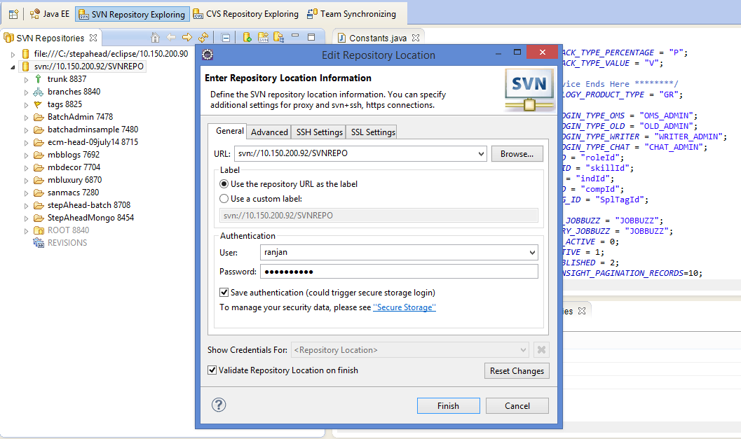

Take the checkout of the Tag given by the dev team like : **ECM-BRANCH-QC-RELEASE-KL_02JUNE15_01**

Explode the **Tags8825** folder and Search in the svn branch and take the checkout of the Tag in your local system.

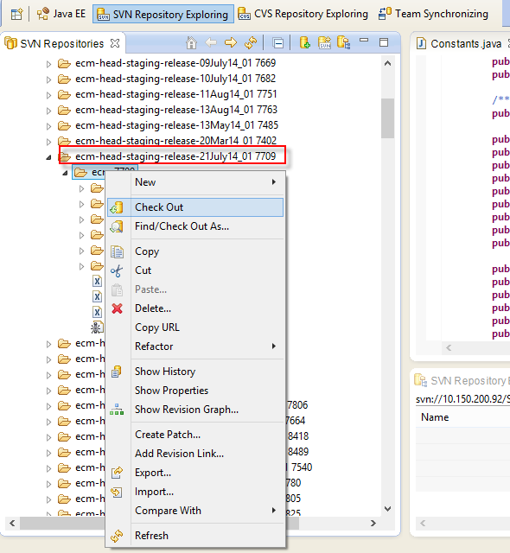

Add ant build in the ANT tab for developer environment.

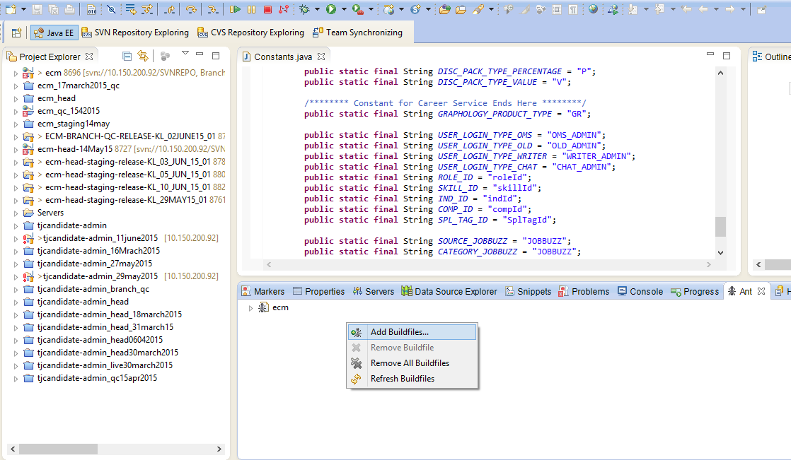

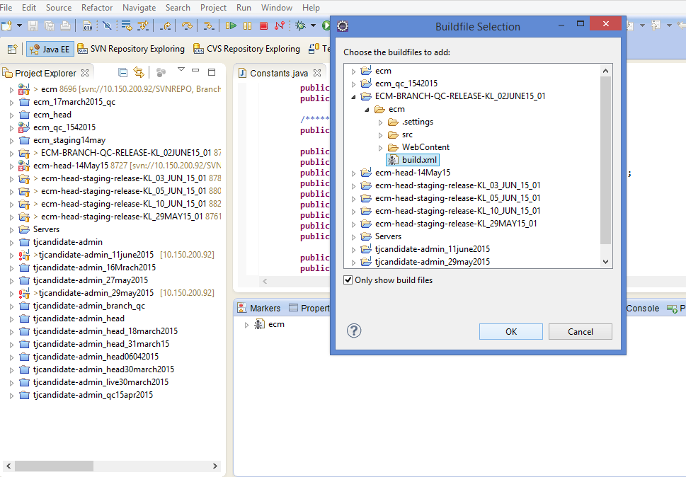

In Ant you need to click the **build-qc** default. A ssuccessfull message displays

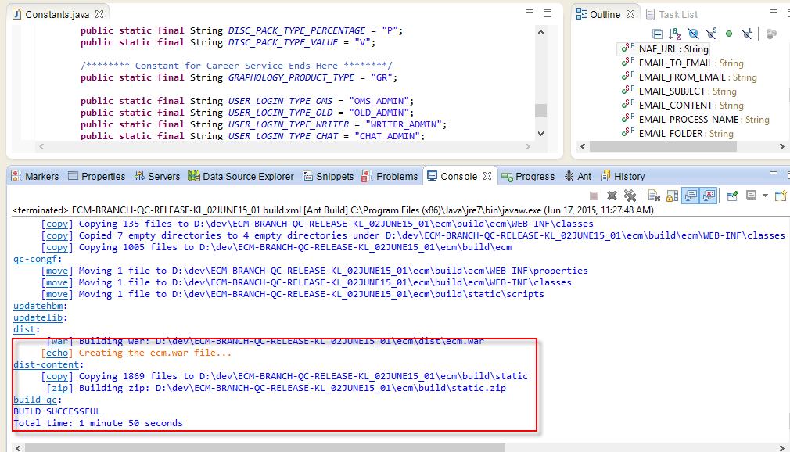

In putty

1) cd /opt/backup

2) mkdir 23feb2015

3) cd /opt/Apache/htdocs

4) cp -r ECM /opt/backup/23feb2015

5)cd /var/lib/jbossas/server/default/deploy

5) In WinSCP: -

1) Got to /opt/Apache/htdocs

2) Remove the existing files(cd /opt/Apache/htdocs)

3) rm -rf ECM

4) mkdir ECM(verify ecm folder)

5) Copy the .zip file(C:\dev\workspace\ECM_QC_RELEASE_20MAY_2012_01\ECM\build) from the Checkout folder.in win scp(local path)

6) Putty: -

1) Go to Putty cd /opt/Apache/htdocs/ECM

2) type unzip.zip(unzip static.zip)

3) rm .zip( rm static.zip)

4) y

7)In WinSCP: -

1) Got to (/var/lib/jbossas/server/default/deploy)

2) In puuty- (cd /var/lib/jbossas/server/default/deploy

2) Remove the existing files (rm -rf ecm.war)

3) Create Directory (mkdir ecm.war)

4) got to ( cd ecm.war)

5) Copy the ecm.war(C:\dev\workspace\ECM_QC_RELEASE_20MAY_2012_01\ECM\dist\) file from the Checkout folder drop in ecm.war folder.

8) Putty: -

1) Go to (cd /var/lib/jbossas/server/default/deploy/ecm.war)

2) type jar -xvf ecm.war

3) rm ecm.war

4) type y and press enter.

9) Restart the server. With command : **service jbossas restart**

**Open(ecmqc.timesjobs.com) to verify the deployment**

**\*\*\*\*\*\*\*\*\*\*\*\*\*\*\*\*\*\*\*\*\*\*\*\*\*\*\*\*\*\*\*\*\*\*\*\*\*\*\*\*\*\*\*\*\*\*\*\*\*\*\*\*\*\*\*\*\*\*\*\*\*\*\*\*\*\*\*\*\*\*\*\*\*\*\*\*\*\*\*\*\*\*\*\***

**On Staging Server: 115.112.206.81.**

**Application is deployed in TOMCAT server.**

**ECM Staging**

**Steps Remains the same as above only diff in ANT Tab.**

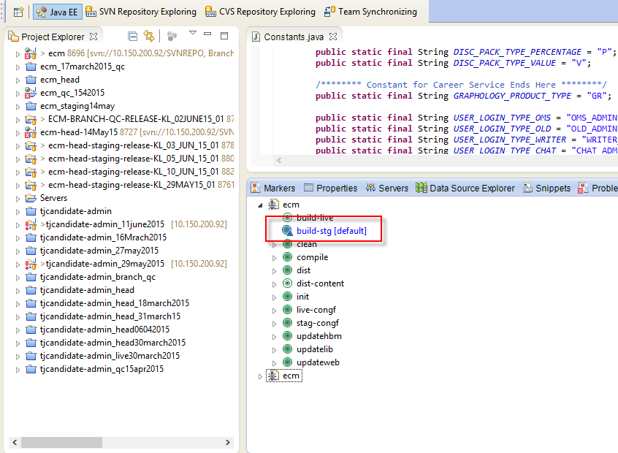

**Double click on Build-stg to create a build on staging and click on build-live to create build for ready live.**

**81 and 102**

**In putty**

**1) cd /opt/backup**

**2) mkdir 4feb2015**

**3) cd /opt/Apache/htdocs**

**4) cp -r ECM /opt/backup/folder name e.g (17june2015)**

**5) cd /opt/tomcat/webapps**

**6) cp -r ecm /opt/backup/17june2015**

**5) In WinSCP: -**

**1) Got to /opt/Apache/htdocs**

**2) Remove the existing files(cd /opt/Apache/htdocs)**

**3) rm -rf ECM**

**4) mkdir ECM(verify ecm folder)**

**5) Copy the .zip file(C:\dev\workspace\ECM_QC_RELEASE_20MAY_2012_01\ECM\build) from the Checkout folder.in win scp(local path)**

**6) Putty: -**

**1) Go to Putty cd /opt/Apache/htdocs/ECM**

**2) type unzip.zip(unzip static.zip)**

**3) rm .zip( rm static.zip)**

**4) y**

**7)In WinSCP: -**

**1) Got to /opt/tomcat/webapps/ecm**

**2) In puuty- cd /opt/tomcat/webapps**

**2) Remove the existing files rm -rf ecm**

**3) Create Directory mkdir ecm**

**4) got to cd ecm**

**5) Copy the ecm.war(C:\dev\workspace\ECM_QC_RELEASE_20MAY_2012_01\ECM\dist\) file from the Checkout folder drop in ecm.war folder.**

**8) Putty: -**

**1) Go to cd /opt/tomcat/webapps/ecm**

**2) type jar -xvf ecm.war**

**3) rm ecm.war**

**4) type y and press enter.**

**9) Restart the server.**

**ps -ef | grep tomcat**

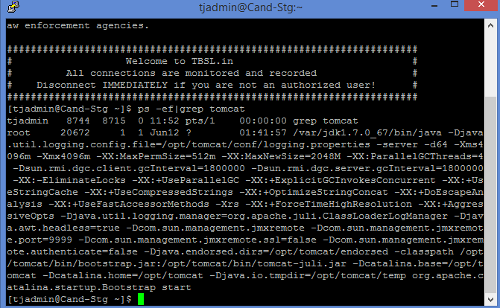

**kill -9 id for e.g here kill -9 20672 and press enter.**

**/opt/tomcat/bin/startup.sh**

**View Log file for any exceptions**

**ecm site cmd :tail –f /opt/ECMlogs/ecm.logs**